Harbormaster Emergency Toolkit Checklist

Essential On-Hand Equipment:
- Tide & drift charts (printed)
- Binoculars
- VHF radios with backup batteries
- Pre-filled incident forms, logbooks
- First aid and volunteer safety kits (PPE, flares, vests)
- Drone access (if available)
- Emergency contact directory (USCG, Marine Patrol, local SAR)

Tide & Drift Prediction Resources:
Keep these tools bookmarked and printed for real-time search planning. Scan QR codes for quick access.

NOAA GNOME Model
Simulates drift trajectory (people, vessels, oil).
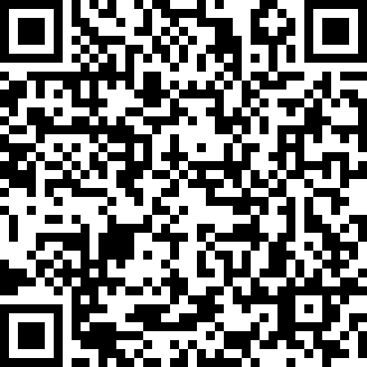

NOAA Tides & Currents
Real-time tide and current data for all US coasts.
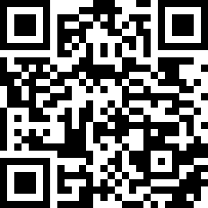

NERACOOS Ocean Data
New England-specific marine forecasts and ocean data.
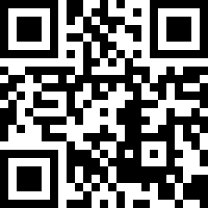

MarineTraffic (wind/current overlays)
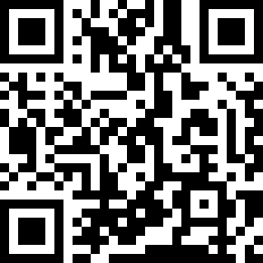
Live vessel tracking with wind/current overlay

Windy.com Marine Forecast
Forecasts wind, wave, and marine conditions worldwide.
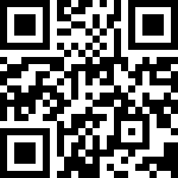

Adrift.org.au (Global Drift Prediction)
Global educational drift tool using ocean currents.
